**Project 1**

**Blackjacks**

**Louidor, Richemond**

**Course: CSC 5**

**SEC: 46091**

**DATE: 07/21/15**

**Table of Contents**

1. **Introduction**
2. **Game Play and Rules**
3. **Development and Logic**
4. **Specifications**

**INTRODUCTION:**

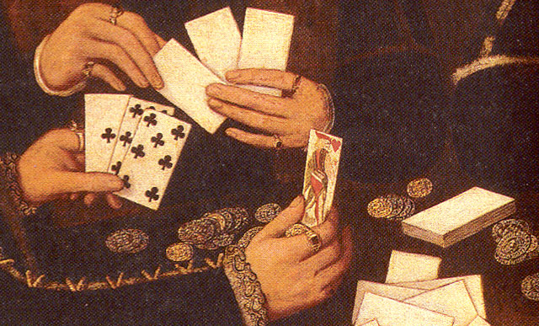Blackjack, also known as twenty-one it is thought that it origins started in France back in the 1700s. Blackjack is widely known and popular game in the United States, mostly common in Casinos. Nowadays, blackjack can be played right from home or on the go either on a smartphone or on a personal computer. Finally I get my chance of creating my own version of blackjack.

**Game Rule:**

1. Winning
   1. Player hit Blackjack (21) on first deal.
   2. Player sum is greater than dealer sum after additional cards are dealt.
   3. Player hit Blackjack (21) after additional cards are dealt.
   4. Dealer bust (dealer sum is >21)
2. Losing
   1. Dealer hit Blackjack.
   2. Player Bust during additional card dealing
   3. Player sum less than computer card sums.
   4. Computer cheats.
3. Push

a. Player sum equal dealer sum (pSum == dSum)

**Game Play:**

1. Greet and Ask for player name.
   1. Player input name
2. Dealer First two cards are dealt.
   1. Dealer card 1 is reveal
   2. Dealer card 2 is hidden
3. Player First two cards are dealt.
   1. Player cards are added up making sure player do not bust on first dealt or if player hit blackjack for an automatic win.
   2. If player sum is less than 21 player decides to hit or stay.
   3. Hit ->to deal a 3rd card and beyond or stay with current cards.
4. Hit
   1. Player sum is greater than 21, player loses.

b. Player sum is equal to 21, player wins .

1. Stay -> stay with current cards.
2. Dealer:
   1. Checking dealer sum to make sure dealer doesn’t bust on first dealt.
   2. Dealer sum is equal to 21 player loses
   3. Dealer hit if sum of first two cards are less than 17.
   4. Dealer stay when sum is equal to or greater than 17.
   5. Player win if dealer sum is greater than 21 during dealer hit.
3. Dealer sum and Player sum are being compare the greater value wins.
4. Game prompt player to play again y/n.
5. Yes game starts over again, No game ends.
6. Game record is written to “blackjack.txt” file.